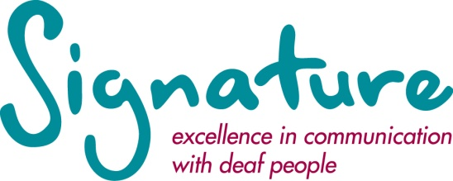

JOB DESCRIPTION

Marketing Assistant

Responsible to: | Marketing Co-ordinator
Job summary: | The prime role of the postholder is to be responsible for providing overall support to the Marketing Coordinator, in line with the marketing strategy.

Key Tasks

1. | Providing overall support to the Marketing Coordinator, in line with the marketing strategy, including; marketing and PR communications, design work, branding, advertising, events, online, promotional items and all other marketing activities.
2. | Assist with content for social media/website including creating new copy for web pages and updating graphics and banners where necessary.
3. | Contribute to creative campaign ideas and work closely with the Marketing Co-ordinator to execute these through all marketing channels.
4. | Assist with communications campaigns to deliver effective and timely communications to key audiences through advertising, social media, press releases, newsletters and direct mail. Logging coverage and response rates.
5. | Accurately maintain company databases. Being observant to trends and customer buyer/engagement patterns.
6. | Monitor and replenish stock of all literature, publications and branded stationery, keeping stock levels appropriate and up to date for the whole organisation.
7. | Compile monthly activity (Google analytics, dotMailer reports, social media reports and any advertising/ sales) to analyse what is working.
8. | Apply and monitor Signature copyright policy.
9. | Comply with brand guidelines when supporting the creation of materials for online and in print.
10. | Carry out any other duties that may reasonably be expected of the postholder.

Relationships

Internal: | Staff at all levels.
External: | External suppliers and customers.

Equipment / Software Used

Microsoft Office Suite
Adobe creative suite
Adobe Acrobat
Telephone/Textphone/Short Message Service (SMS)

Updated 01/16

PERSON SPECIFICATION
Marketing Assistant

Requirements | Essential | Desirable
Education/  Qualifications | - General education levels to GCSE and A level or equivalent. | - A - Level English.  - Educated to Degree level or equivalent.  - Recognised marketing qualification.
Experience | - Marketing/PR experience in a small to medium organisation.  - Experience in copywriting and design. | - Understanding of deaf and disability issues and the issues facing providers in the not-for-profit sector  - Be able to adapt tone and messages for different brands.
Knowledge | - Knowledge and experience of working in a competitive market.  - Excellent computer skills including design packages. | - Understanding of design and print production processes.  - Up-to-date knowledge of appropriate accessibility standards for printed materials.
Skills and  Abilities | - Strong initiative, drive and a flair for creativity and innovation.  - Flexible and adaptable.  - Good general administration and organisational skills.  - A positive team player with the ability to think and act on ones own initiative in an integrated marketing environment.  - Good time management.  - Excellent interpersonal skills, able to deal with people at all levels.  - Excellent oral and written presentation skills, specifically written English.  - The ability to analyse statistical data and collate complex information.  - A high level of proof reading accuracy and attention to detail.  - Ability to work under pressure and meet deadlines.

Location and working hours | Mersey House, Mandale Business Park, Belmont, Durham, DH1 1TH. This is a non-smoking building. Working hours – full-time 37 hours per week, Monday to Friday.
Holidays | 25 working days per year plus recognised bank or public holidays currently 8 in all. Of the 25 days holiday, you must keep up to 3 days each year to bridge the gap between Christmas and the New Year, when the office closes.
Salary | The salary for this post is up to £18,000 dependant on experience (gross per annum).
Requirements | Employees are expected to complete the following Signature courses within 2 years of commencing employment:  - Level 1 Award in British Sign Language.  - Level 1 Award in Deaf Awareness and Communication.
Pension | Signature operates a voluntary pension scheme through the Pensions Trust.

Updated 01/16

